Name: Weekly Language Review – Q1:2 Date:
Monday | Tuesday | Wednesday | Thursday
Write the missing letters.  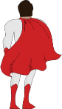  c___ p___ | Write the missing letters.  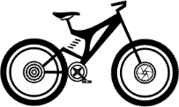  b___ k___ | Write the missing letters  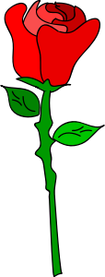  r___ s___ | Write the missing letters.  c___ b___
Write the word.  me | Write the word.  my | Write the word.  we | Write the word.  you
Circle the letters that should be capitalized.  the cat ran up the tree. | Circle the missing ending punctuation.  ! . ?  I am at school___ | Circle the letters that should be capitalized.  emma and i are coloring. | Circle the missing ending punctuation.  ! . ?  Where are you___
Color the NOUNS blue.  Color the VERBS green.  house drive  car watch | Underline the NOUN in the sentence.  The dog ran. | Color the NOUNS blue.  Color the VERBS green.  sleep drink  water ice | Underline the VERB in the sentence.  The dog ran.
Circle the words that are places.  park one game  swing store  bone library eye | Write a word that is a drink.  _____________________ | Circle the words that are fruits.  orange arm pen  berry carrot  cheese banana | Write a word that is an animal.  _____________________
Circle the picture that matches the word.  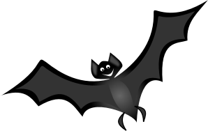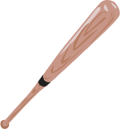  The bat lives in a cave. | Circle the picture that matches the word.  He hit the ball with the bat. | Circle the picture that matches the word.  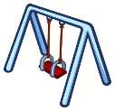  I love to play at the park. | Circle the picture that matches the word.  My sister was in a play.
My Work
Monday  __________________________________________________________________________________________________________________________________ | Tuesday  __________________________________________________________________________________________________________________________________
Wednesday  __________________________________________________________________________________________________________________________________ | Thursday  __________________________________________________________________________________________________________________________________

My Progress
MONDAY  Out of _____ questions, I got ______ correct. | TUESDAY  Out of _____ questions, I got ______ correct. | WEDNESDAY  Out of _____ questions, I got ______ correct. | THURSDAY  Out of _____ questions, I got ______ correct.

Answer Key - Weekly Language Review – Q1:2

Monday | Tuesday | Wednesday | Thursday
Write the missing letters.  cape | Write the missing letters.  bike | Write the missing letters  rose | Write the missing letters.  cube
Write the word.  me | Write the word.  my | Write the word.  we | Write the word.  you
Circle the letters that should be capitalized.  The cat ran up the tree. | Circle the missing ending punctuation.  ! . ?  I am at school___ | Circle the letters that should be capitalized.  Emma and I are coloring. | Circle the missing ending punctuation.  ! . ?  Where are you___
Color the NOUNS blue.  Color the VERBS green.  house drive  car watch | Underline the NOUN in the sentence.  The dog ran. | Color the NOUNS blue.  Color the VERBS green.  sleep drink  water ice | Underline the VERB in the sentence.  The dog ran.
Circle the words that are places.  park one game  swing store  bone library eye | Write a word that is a drink.  Answers will vary.  juice | Circle the words that are fruits.  orange arm pen  berry carrot  cheese banana | Write a word that is an animal.  Answers will vary.  lion
Circle the picture that matches the word.  The bat lives in a cave. | Circle the picture that matches the word.  He hit the ball with the bat. | Circle the picture that matches the word.  I love to play at the park. | Circle the picture that matches the word.  My sister was in a play.

